# K-Nearest Neighbors

**Instructions:**

Please share your answers filled in-line in the word document. Submit code separately wherever applicable.

Please ensure you update all the details:

**Name: _Radhakrishna Naik Batch ID:07012022**

**Topic: K-Nearest Neighbors**

**Hints:**

1. **Business Problem**
   1. **What is the business objective?**
   2. **Are there any constraints?**
2. **Work on each feature of the dataset to create a data dictionary as displayed in the below image:**

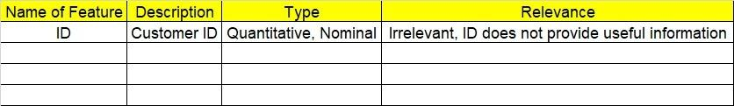

**2.1 Make a table as shown above and provide information about the features such as its data type and its relevance to the model building. And if not relevant, provide reasons and a description of the feature.**

1. **Data Pre-processing**

**3.1 Data Cleaning, Feature Engineering, etc.**

1. **Exploratory Data Analysis (EDA):**
   1. **Summary.**
   2. **Univariate analysis.**
   3. **Bivariate analysis.**
2. **Model Building**
   1. **Build the model on the scaled data (try multiple options).**
   2. **Perform KNN and use cross validation techniques to get optimum K value.**
   3. **Train and test the model and perform cross validation techniques. Compare accuracies, precision and recall and explain them in the documentation.**
   4. **Briefly explain the model output in the documentation.**

1. **Write about the benefits/impact of the solution - in what way does the business (client) benefit from the solution provided?**
2. A glass manufacturing plant uses different earth elements to design new glass materials based on customer requirements. For that, they would like to automate the process of classification as it’s a tedious job to manually classify them. Help the company achieve its objective by correctly classifying the glass type based on the other features using KNN algorithm.

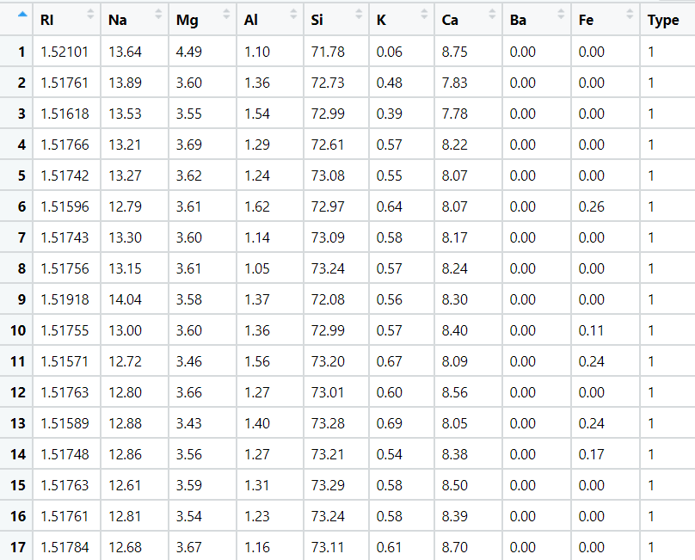

1. 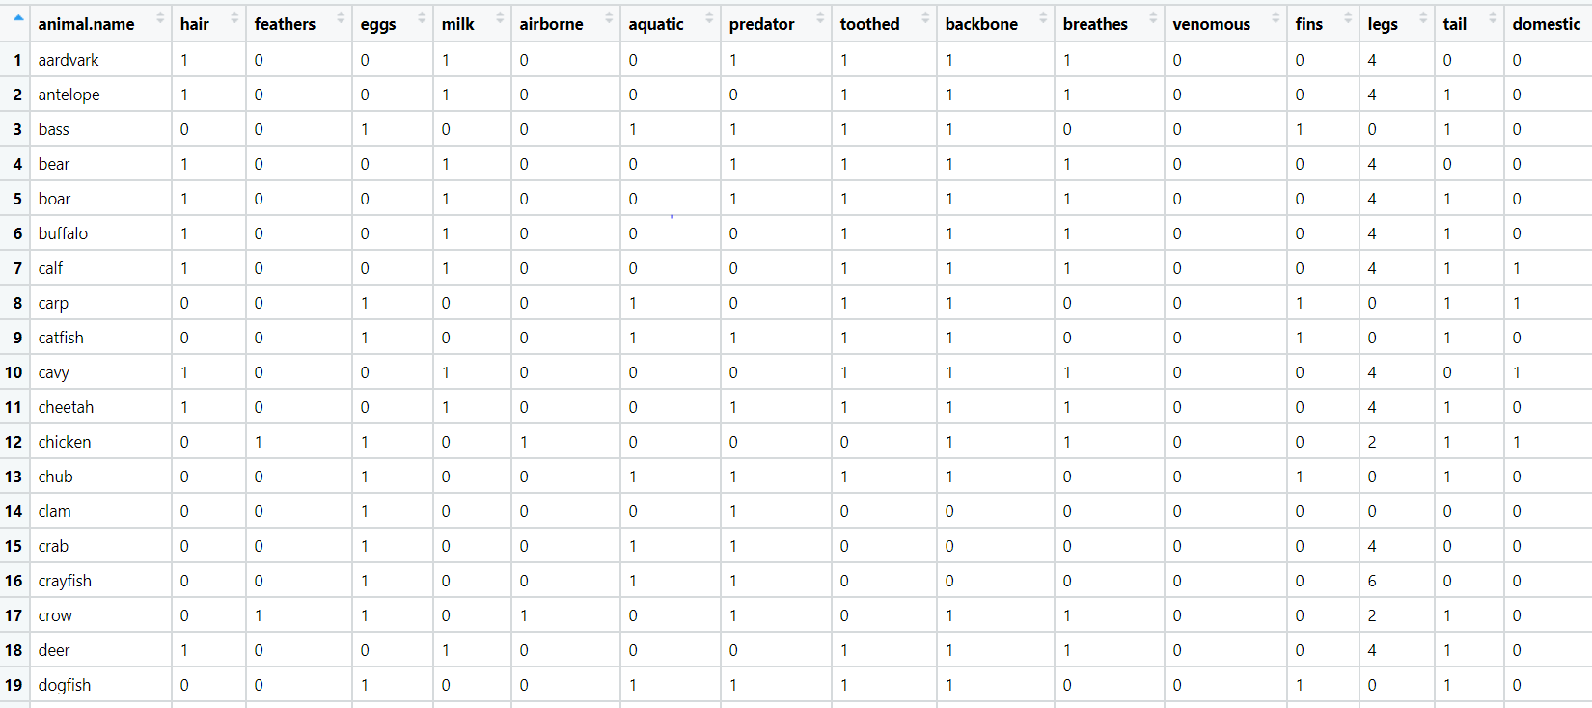A National Zoopark in India is dealing with the problem of segregation of the animals based on the different attributes they have. Build a KNN model to automatically classify the animals. Explain any inferences you draw in the documentation.